Name:POOJA S
Regno:192524211

1.
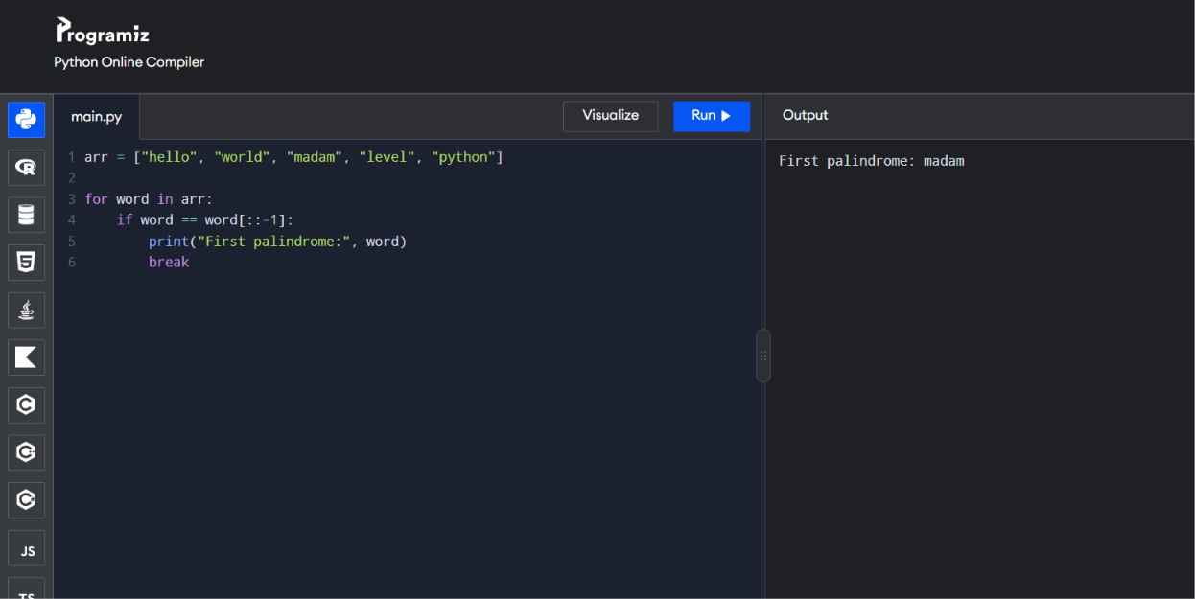
Time Complexity: O(n²)
Space Complexity: O(n)
2.
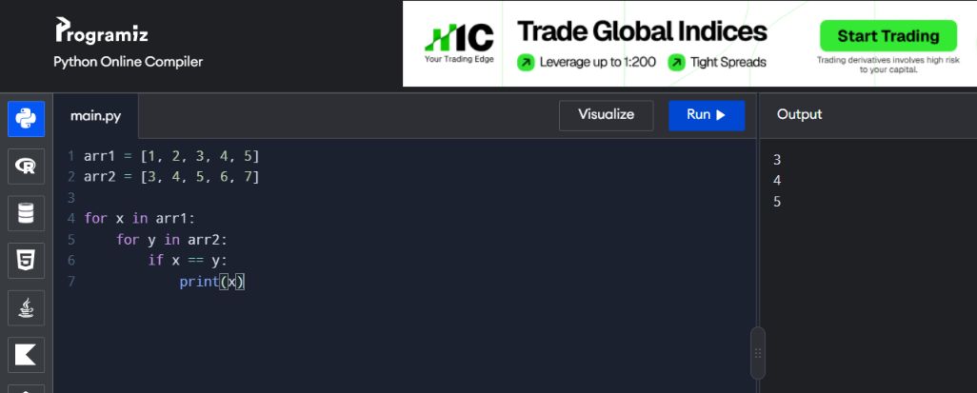
One loop inside another = Nested loops = O(n²)

3.
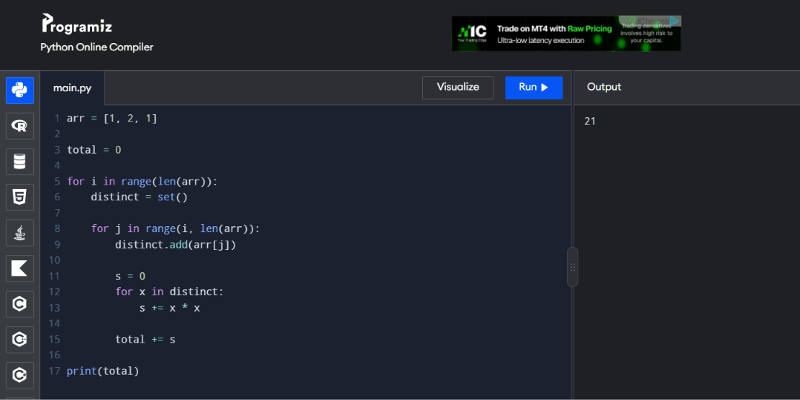

4.
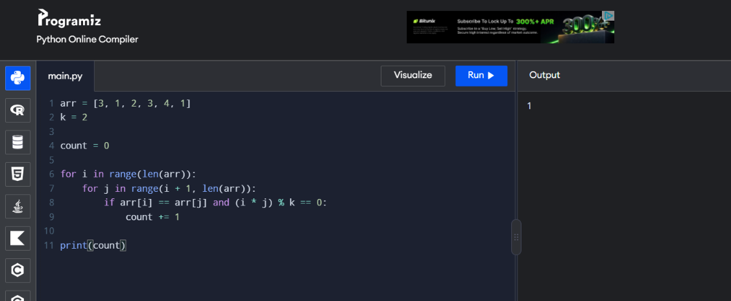
5.
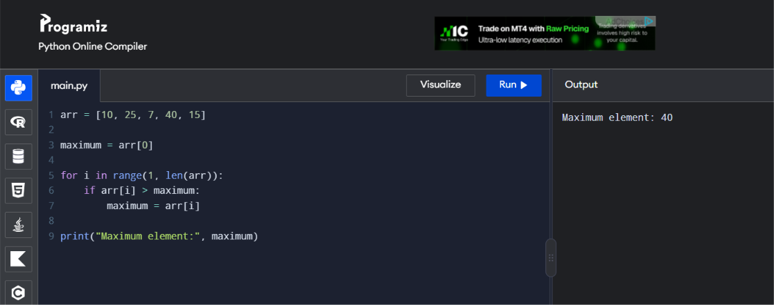
Time Complexity = O(n)

